**PES University, Bangalore**

(Established under Karnataka Act No. 16 of 2013)

**MAY 2020: IN SEMESTER ASSESSMENT (ISA) B.TECH. IV SEMESTER**

**UE18MA251- LINEAR ALGEBRA**

MINI PROJECT REPORT

ON

“Linear algebra in Traffic Flow”

Submitted by

1.Shashank Bhari H B SRN: PES1201801601

2.Sai Pranav Madineni SRN: PES1201800

3.Rohan Bennur SRN: PES1201801

Branch & Section : Computer Science - ‘C’ Section



PROJECT EVALUATION

( For Official Use Only )

|  |  |  |  |
| --- | --- | --- | --- |
| Sl.No. | Parameter | Max Marks | Marks Awarded |
| 1 | Background & Framing of the problem | 4 |  |
| 2 | Approach and Solution | 4 |  |
| 3 | References | 4 |  |
| 4 | Clarity of the concepts & Creativity | 4 |  |
| 5 | Choice of examples and understanding of the topic | 4 |  |
| 6 | Presentation of the work | 5 |  |
|  | Total | 25 |  |

Name of the Course Instructor : P RAMA DEVI

Signature of the Course Instructor :

**INTRODUCTION:**

Traffic congestion has a number of negative effects on humanity. Traffic problems have drastically increased in Indian major cities as compared to the last two decades .Hence countless hours are being wasted in traffic these days. But fortunately mathematicians came with the “Systems of Linear Equations” Concept to reduce these problems.

In this current study we are facing a critical traffic problem of four one ways (Diagram is shown in one of the following pages) .Where each one way has ‘X’ vhp(vehicle per hour) coming in or going out of the intersection.By the end of this we try estimating the vehicular traffic in each road / street and the number of vehicles that should be allowed to route the four one-way streets under study in the model in order to reduce traffic congestion at the intersection .

**LITERATURE SURVEY:**

In [1], this paper aims at a Mathematical Model for Phantom Jams and Gauss Jordan elimination for traffic flow.In Phantom Jams traffic lines spread backwards like waves , moving very farther .Phantom jams are compared to similar mathematical models of fluid flow So, Phantom jams can not be fixed but can be considerably slowed down. Certain formulas are given to estimate traffic density.

[1] Traffic flow is solved by Gauss Jordan Elimination,which predicts the number of vehicles passing through each road/ street.

In [2],Researchers in Italy studying noise level from traffic jams at a three -way intersection,used the System of linear equations to model the traffic flow at the intersection.Gauss Jordan method is used to solve some interesting puzzles.

In [3], Linear algebra and its applications by Gilbert Strang explains Gaussian Elimination ,Temporary and Permanent break down ,LDU Matrix Decomposition ,Permutation Matrices and Gauss Jordan method very clearly for the readers.Gauss Jordan method has numerous application like calculating Inverse of matrix and solving System of linear Equations ( ex. Traffic Flow).

In[4], Linear Algebra with Applications by Garet Wiiliams explains systems of linear equations very precisely. Application level problems are stated/given in the book for users' clear understanding of concepts.

**MATHEMATICAL MODEL /REPORT ON INVESTIGATION:**

A system of linear equations was used to analyze the flow of traffic for a network of four one-way streets.The variables x,y,z and w, represent the flow of the traffic between the four intersections in the network. The data was obtained by counting the number of vehicles that travelled around the four one-way streets between the hours of 6am to 10pm, and 2pm to 6pm during the mid-week peak traffic hours.

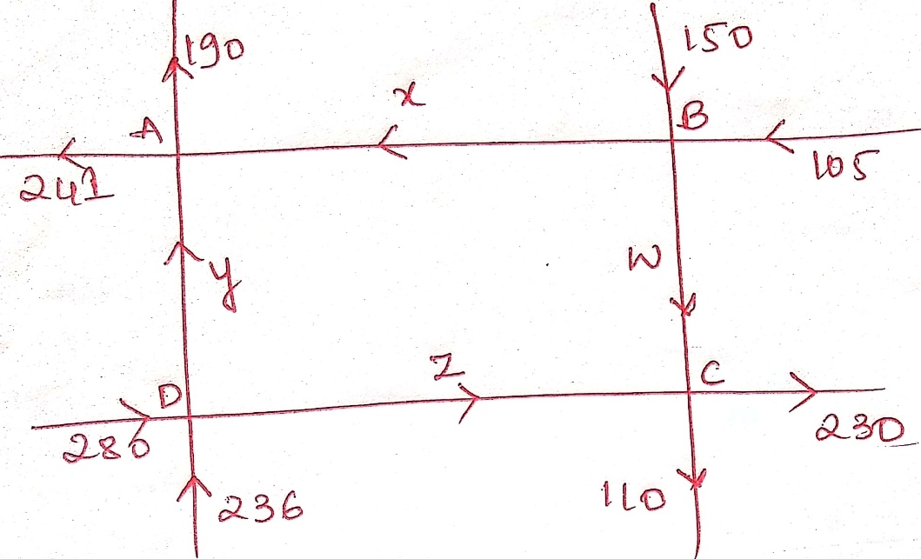

The arrows in the diagram indicate the direction of flow of traffic in and out of the network that is measured in terms of number of vehicles per hour (vph).

**Few Assumptions:**

To ensure the smooth flow of traffic at the junction, here we made few assumptions :

1. Vehicles entering each intersection should always be equal to the number of vehicles leaving the intersection.
2. The streets must all be one-way with the arrows indicating the direction of traffic flow

System of linear equations for the above diagram is:

Calculating traffic at each intersection ,

A:Traffic : in=100+200 ,traffic out=x+y therefore , x+y=300.

B: Traffic : in=x+w,traffic out=100+150 therefore , x+w=250

C: Traffic : in=50+50 ,traffic out=z+w therefore , z+w=100.

D: Traffic : in=y+z ,traffic out=50+100 therefore , y+z=150.

Hence we now have,

x+y=300.

x+w=250

z+w=100.

y+z=150.

Constructing augmented matrix and performing Gauss Jordan Method to solve the system of linear equations.The row-reduced echelon form of the above system of linear equation is:

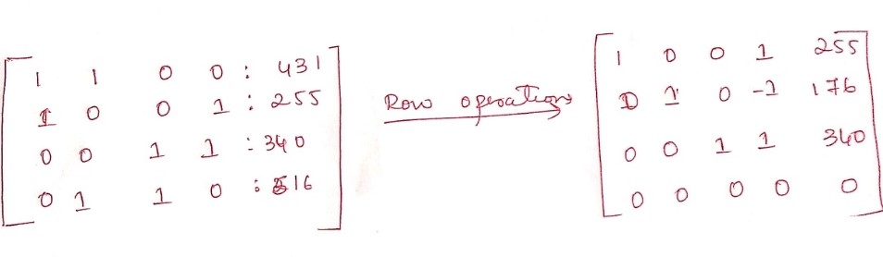

From the above row reduced form , system of linear equation is :

x+w=255

y-w=176

z+w=340

Now , expressing each variable in terms of another variable, we have:

x=-w+255

y=w+176

z=-w+340

Hence if we know the speed between B and C intersection then we can predict the speed on other roads/streets.

**RESULTS AND DISCUSSIONS:**

The system of the modeling equations has many solutions, and therefore many traffic flows are possible. A driver has a certain amount of choice at the intersection, due to the nature of the model. But when we analyze the above system of linear equations along stretch DC , it is desirable to have small traffic flow z as possible along this stretch of road.

Therefore, the traffic can be controlled along the various branches by the use of traffic lights. According to the model, the third equation in the system shows that z will be a minimum when w is as large as possible, as long as it does not exceed 340. Without causing negative values in x and y we can assume the largest value of w 255. But the smallest value of w is -255+340 or 85.

Thus the minimum speed / traffic flow along the BC should be at least 85vhp.Therefoer to keep traffic flowing g 240vph must be routed between D and C, 155vph between A and B and 276vph between the intersections A and D.

This study will be helpful to :

1. Pre-estimate the Vehicular Traffic.
2. This estimation will save time in the traffic, making the people to reach their destination faster than before(because now people know what is the density of the vehicles on each road beforehand).

**CONCLUSIONS:**

We have established that traffic congestion at the four one-way can be minimized if any road work on Asafo interchange to Roman hill down should allow for traffic volume of at least 85vph. Therefore, to keep the traffic flowing, 240 vehicles per hour must be routed between D and C, 155vph between A and B , and 276vph between the intersections A and D respectively

**REFERENCES:**

1). Keerthika C1, Narahari Greeshma2, Priya Vyshnavi3, Keerthan Kumar Reddy4, and K. Indhira5, V.M. Chandrasekaran6, Mathematical Model For Traffic Flow,International Journal of Engineering and Technology ,pp 940-941.

2). Sakthivel A, and Kavitha T.N, A Trail To Solve The Puzzles By Modeling Linear Equations And Using Gauss-Method,International Journal Of Recent Scientific Research 2016,pp 13777-13781.

3). Gilbert Strang , Linear Algebra And Its Applications,Fourth Edition, Chapter 1,pp 4-66,Publisher- Thomson, Brooks/Cole,year-2007.

4). Gareth Williams , Linear Algebra with Applications,Ninth Edition, Chapter 1,pp 37-38,Publisher- Jones and Bartlett,year- 2014.